Basic docker commands
Command-help
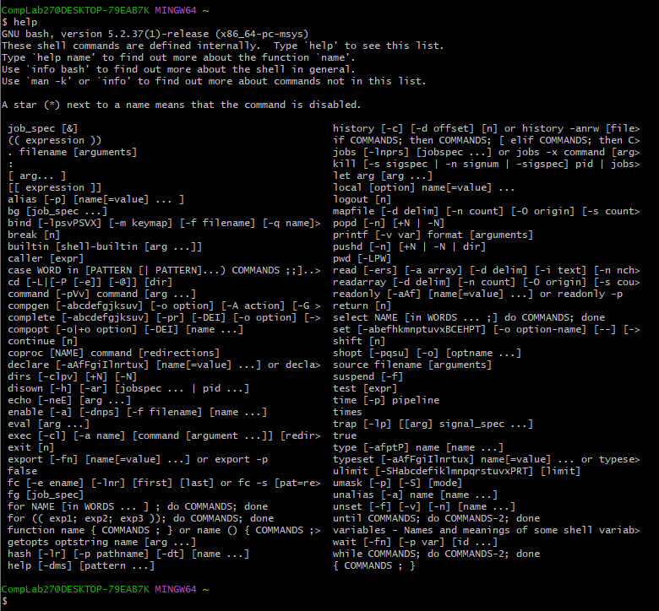

Command-clear
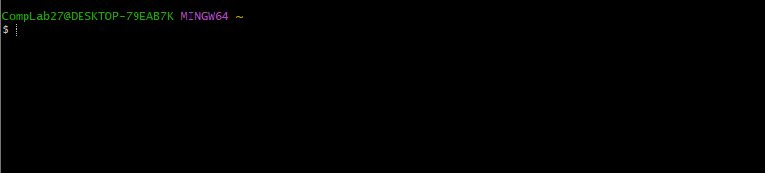
Docker run Ubuntu # to fetch the image
Docker run –it Ubuntu # to pull and run the image
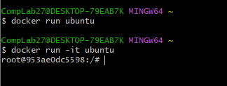

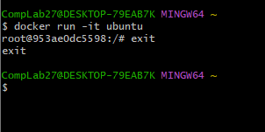
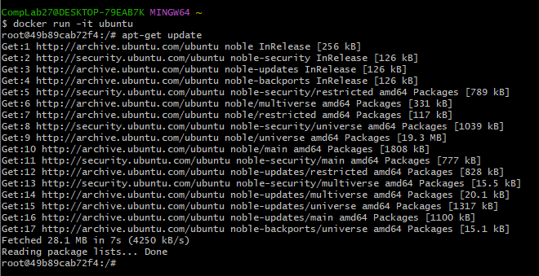
Apt-get install –y curl
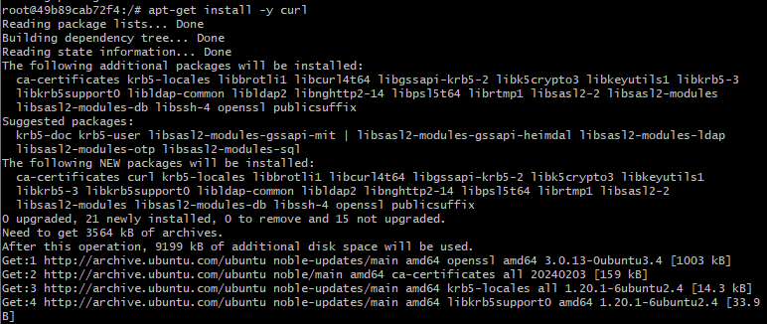

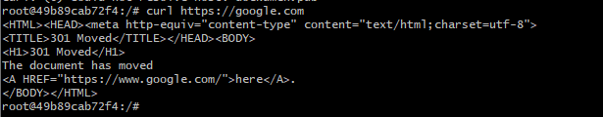
Docker run alpine # alpine is a lightweight Docker imager based on alpine Linux distribution . mostly it is used for developers building containerized apps.
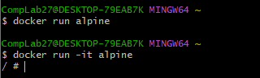
Docker run –d –P –-name nginx2 nginx:alpine # create nginx2 project in alpine container
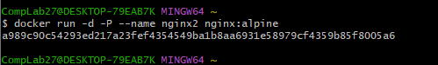
Docker container port nginx2 # port of nginx2 project for deploying
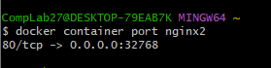
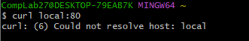
Or go to chrome type- localhost:808

AIM: creating python file in ubuntu container

$ winpty docker run -it ubuntu
root@63c62ed0402a:/# apt-get update

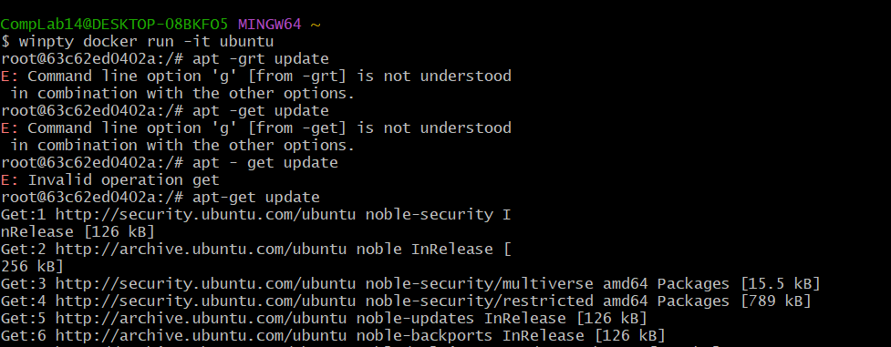

root@63c62ed0402a:/# apt-get install -y python3-pip
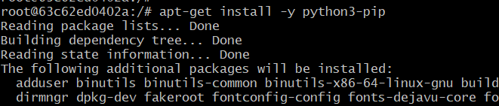

root@63c62ed0402a:/# cat > test_1.py
print("hello class") # press cntrl d to get out
root@63c62ed0402a:/# python3 test_1.py
hello class

